User Manual

Line Manager User Training Manual for
Oracle Fusion HCM Cloud

Authors : Charu Vohra
Creation Date : 13-July-2019
Last Updated : 18-Sep-2020
Control Ref :
Version : Ver1.1

Document Control

Change Record
32
Date | Authors | Version | Change Reference
13-07-2019 | Charu Vohra | 1.0 | Initial Document
18-Sep-2020 | Sheryar Shami | 1.1 | CR2 changes (role delegation and vacation rule short cut)

Related Documents

No. | Document Link | Document

Reviewers

Name | Position

Distribution
Copy No. | Name | Location

Acknowledgements

Name | Meeting/E-Mail

Note to Holders:
If you receive an electronic copy of this document and print it out, please write your name on the equivalent of the cover page, for document control purposes.
If you receive a hard copy of this document, please write your name on the front cover, for document control purposes.

Contents
Document Control 2
Change Record 2
Related Documents 2
Reviewers 2
Distribution 2
Acknowledgements 2
1. Assignment/Employment Data 5
2. Manage Allocated Checklist 8
3. Work Schedule management and Assignment 11
4. Work Relationship (Resignation/Termination) 12
5. Absences Records 14
6. Approval Requests 15
7. Directory 18
8. Learning 20
9. Delegation of Access for Approvals 21
10. Role Delegation and Vacation Rule/Approval Delegation Short Cut 23

1. Assignment/Employment Data

Line Manager will be able to review the most recent assignment details of the Staff.
- Log into HCM using the login credentials using Username and Password.
- Copy and paste the below given URL in the browser address bar. Use Bookmark option to save this URL for regular use.
https://eqdj.login.em8.oraclecloud.com/
OR
Through Etisalat intranet page

- On the login page, click on Company SingleSign-On
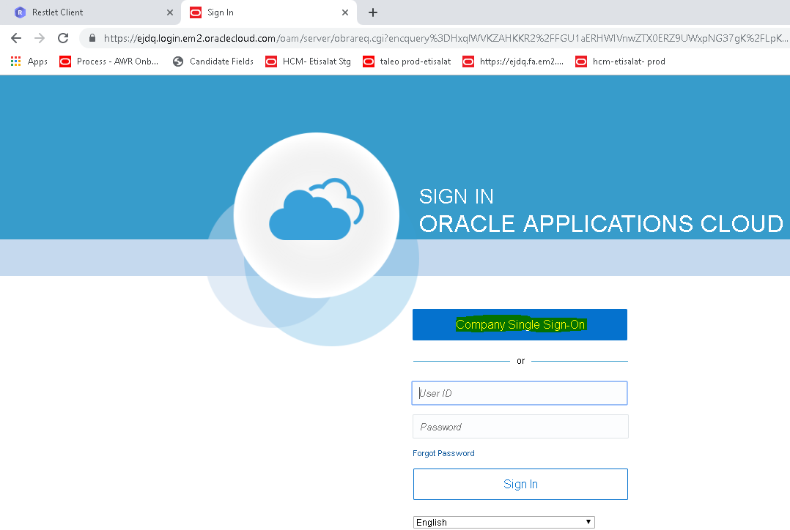

Home Page appears
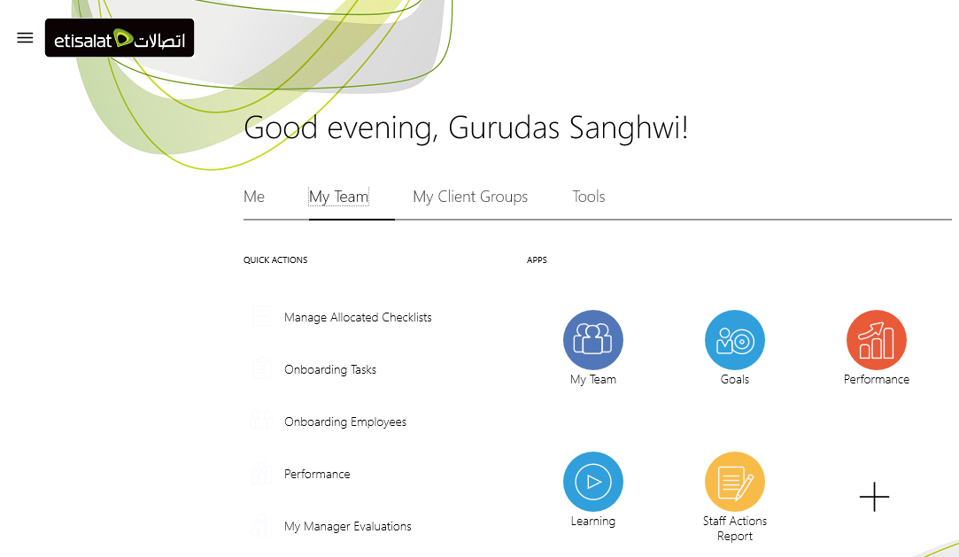
- Select My Team from the home page.
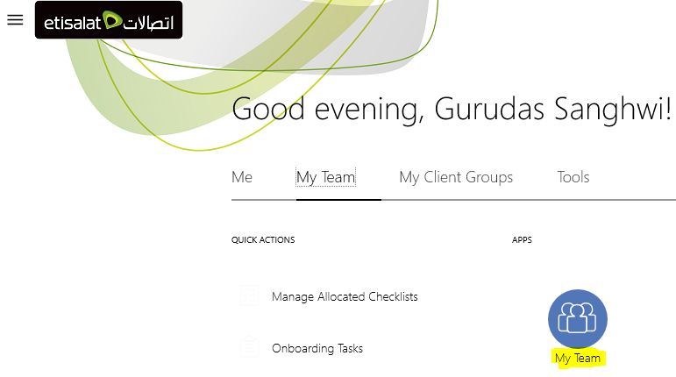
- The next page will show the list of the Staff(s) reporting to the manager.
- To access the Staff record, take one of the following steps
- Click on Staff Name hyperlink.
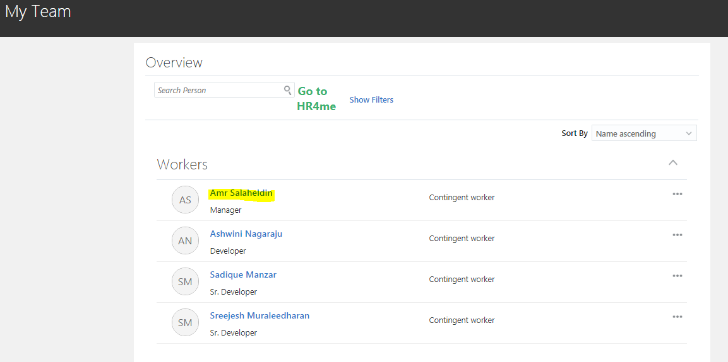
- It will take you to the Employment Info page. Please note that line manager will have view only access to the Employment page.
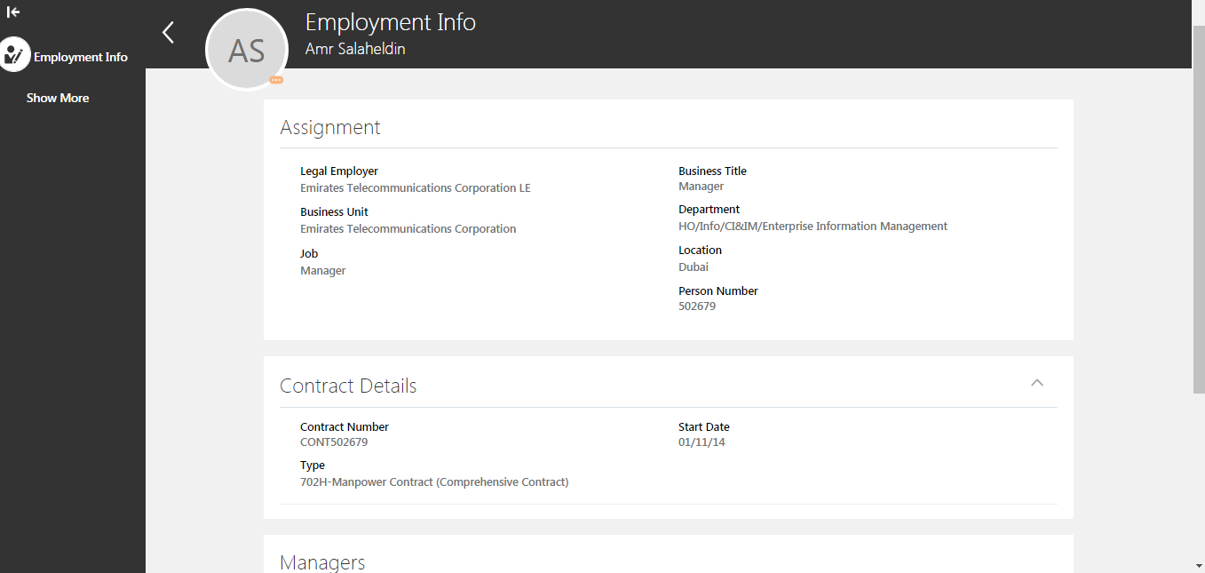

2. Manage Allocated Checklist

- Line Manager can view and manage allocated checklist for the Staff. Select Managed Allocated Checklist from Personal and Employment tab under Actions.
- The checklist will trigger emails(tasks) to the concerned team(s) including Line Manager as per the below matrix.
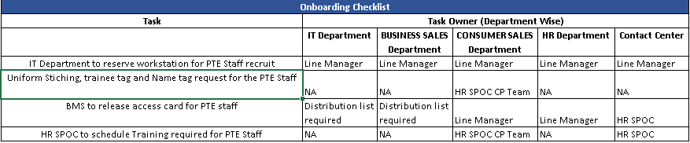
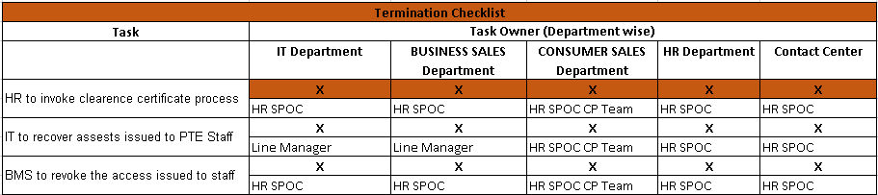
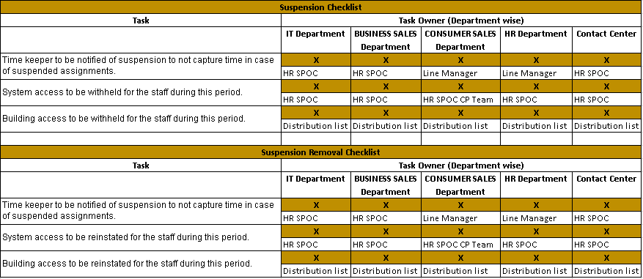
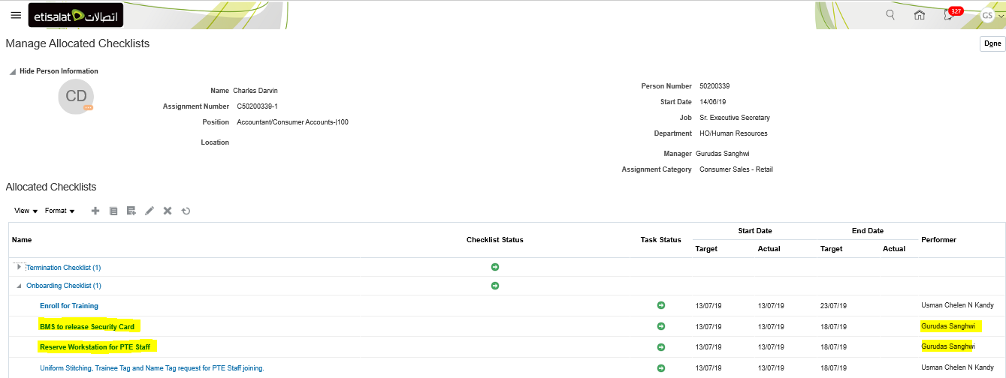
- For Example; the below email notification will be received by the concerned team(s) to initiate the onboarding tasks. A user can mark the task as completed or not applicable through email itself and the results will get updated in the system.
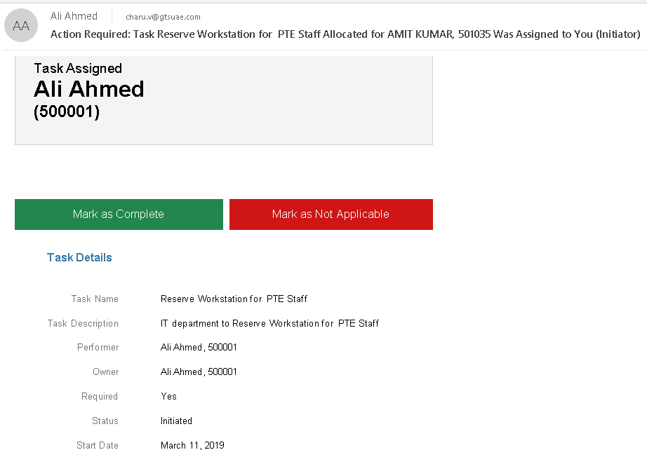
- If required, the status of the task(s) and checklist can also be monitored/updated by the Line Manager.
- In the checklist, you can edit and update the status of the checklist and/or task(s), if needed. Once all the assigned tasks are completed, the status of the checklist automatically changes to Completed.
- Example; the below email notification will be received by the concerned team(s) to initiate the termination tasks. A user can mark the task as completed or not applicable through email itself and the results will get updated in the system. Similarly, they can update the status in the system directly.
- To update the task(s) directly in HCM, select the concerned task and click Edit
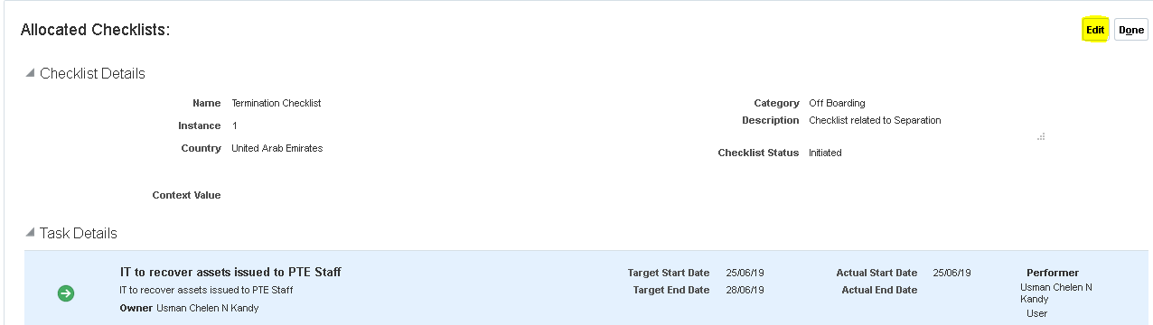
- In the task details section, click on pencil icon to edit the task.
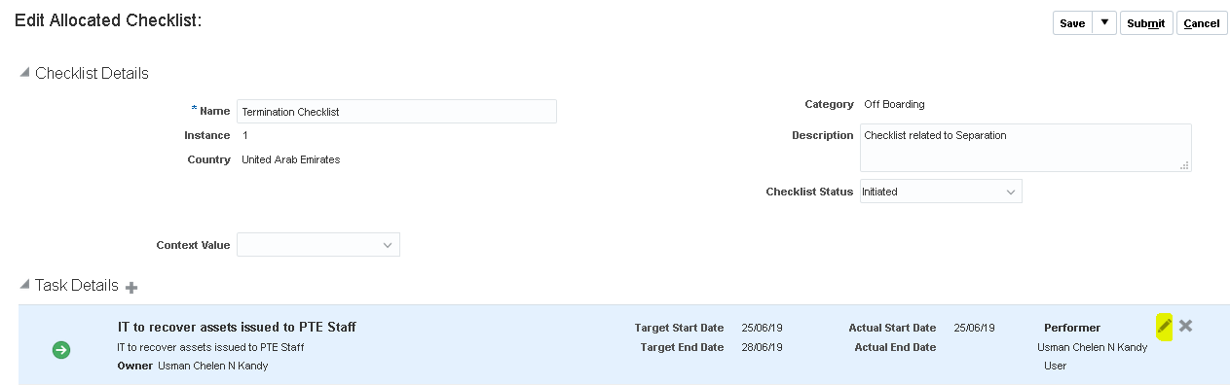
- Change the Status to Completed, Inprogress etc as per the requirement.
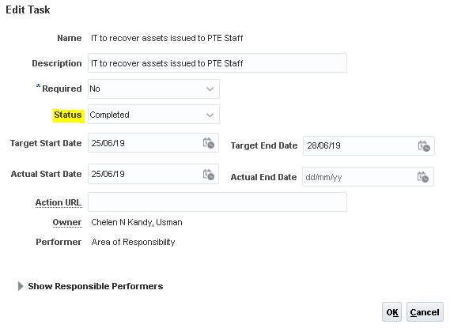

3. Work Schedule management and Assignment

Each Staff must be assigned to a work schedule as this has direct impact on absences and timecards.
A default work schedule of 7am to 3pm, 5days per week is already assigned at a legal employer level. However, for the staff working in night shifts or 6-day work schedule must have work schedule assigned.
- Click on Manage Work Schedule from Personal and Employment under Actions.
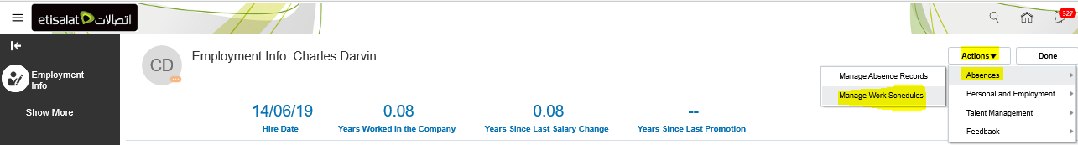
- Select the required work schedule from the list, change the Start and End dates (if needed)
- Select Yes in the Primary
- Click on Review and then Submit the changes.
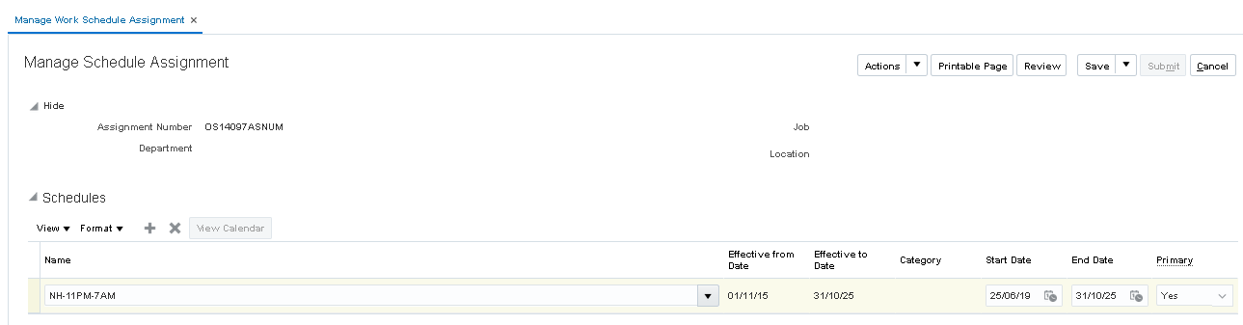

4. Work Relationship (Resignation/Termination)

This page will show separation details of the Staff.
From the Employment Info page, select “Manage Work Relationship” from Personal and Employment under Actions. The Resulting window is shown below:
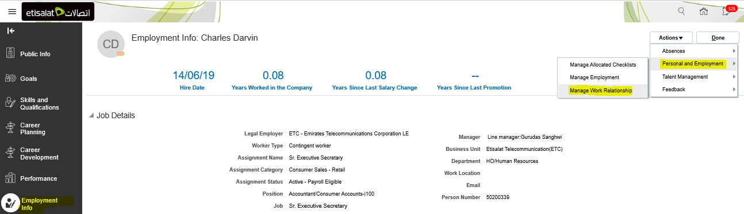
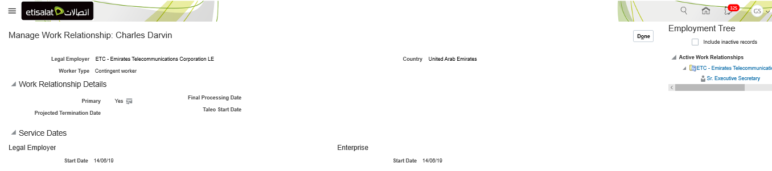

5. Absences Records

There are various types of absences which can be submitted by the Staff. These leave types will be visible for the staff(s) as per their eligibility criteria.
Leave Type | Eligibility to apply via HCM
Annual Leave | Applicable to all the Staff
Sick Leave | Applicable to all the Staff
Maternity Leave | Female Staff
Child Nursing | Female Staff
Hajj Leave | Staff based on Islam Religion
Compassionate Leave | Applicable to all the Staff
Unpaid Leave | Applicable to all the Staff
Training Leave | Applicable to all the Staff
Duty Travel | Applicable to all the Staff
Compensatory Leave | Applicable to IT Staff
Uncertified Sick Leave | Applicable to Staff in 702H Special Contract 1 and 2

- Click on Manage Absences > Personal and Employment tab under Actions.
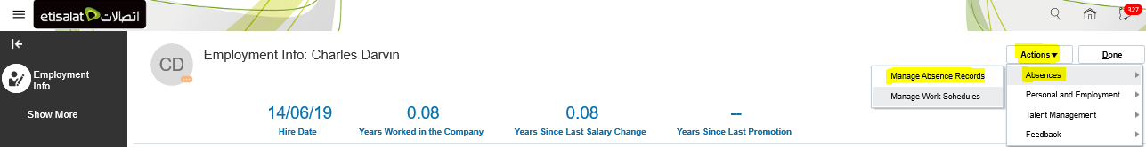
- A Line Manager can also apply for an absence on behalf of the Staff, if needed.
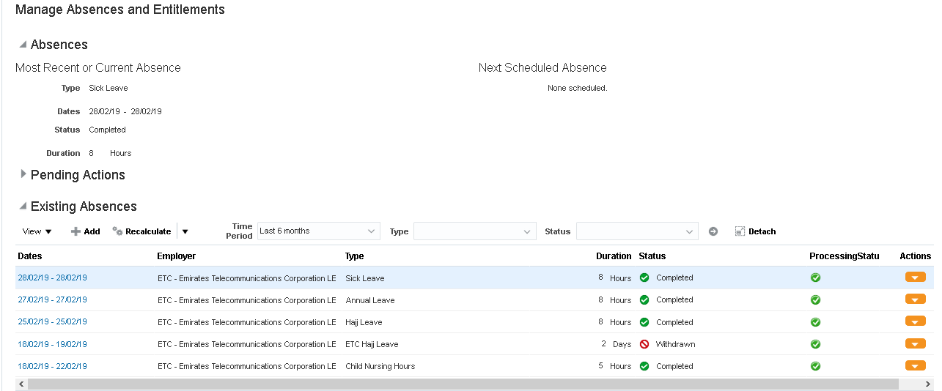
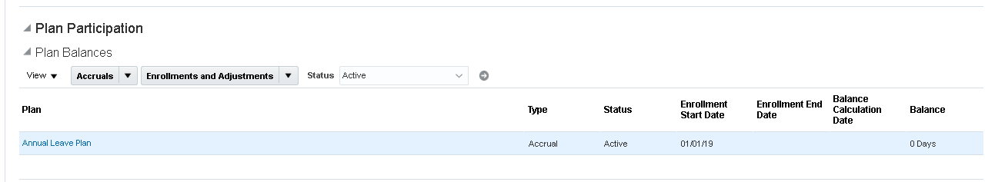

6. Approval Requests

The Line manager will receive request for approval in various transactions:
- Benefit Requests
- Expenses
- Bank Details
- Document Records (work permit, visa etc)
- Leave of Absence
- Separation – Staff initiated (Resignation)

The Manager will receive the approval email in his/her mailbox and as a notification (under bell icon) in the HCM Home page.
Example of Notification:
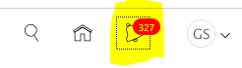
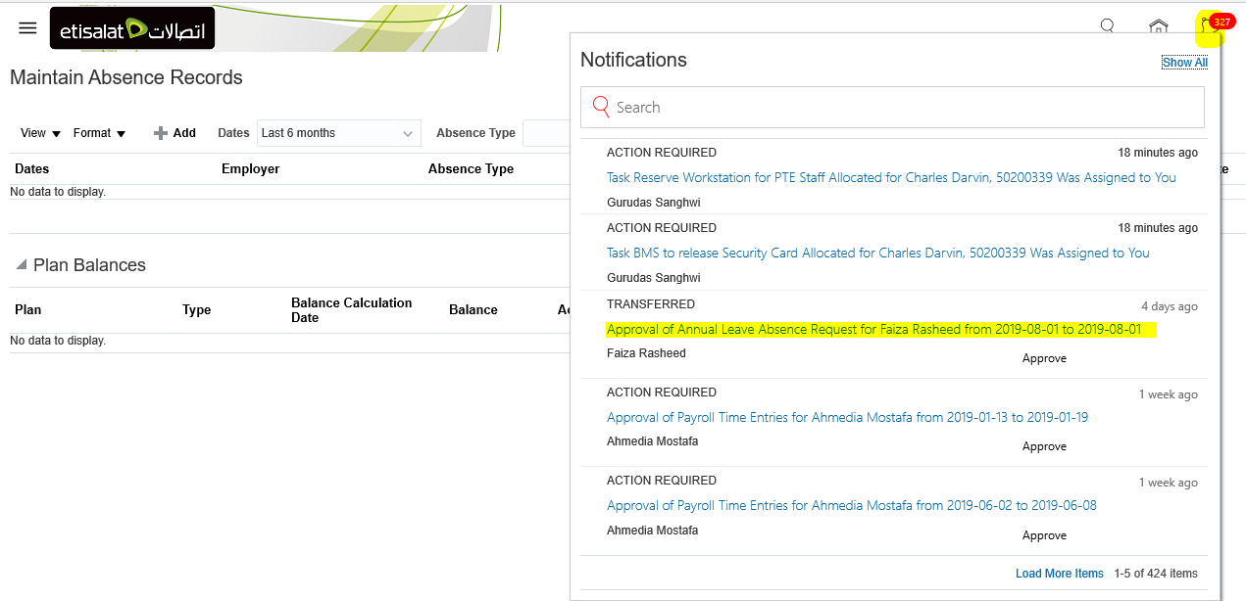
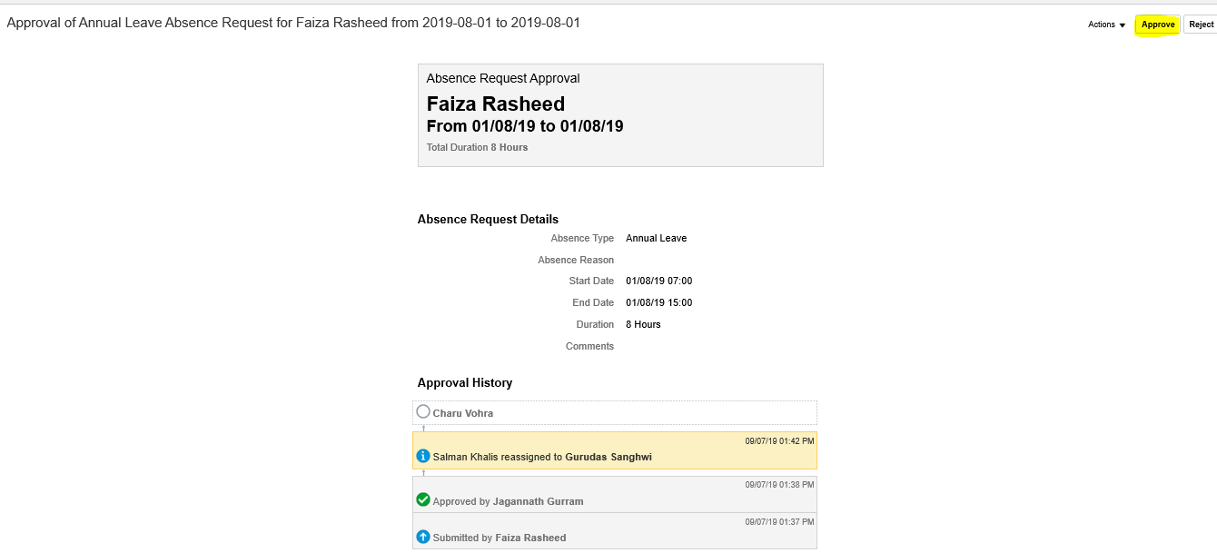

Example of Email in the Mailbox

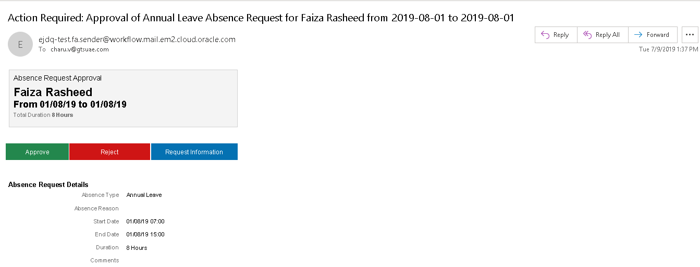
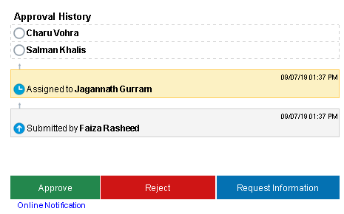

7. Directory

Directory will allow user to look and search for the staff records outside your hierarchy. It will allow user to view the organisation structure/hierarchy for any fellow staff.
- Under Me, select Directory from the Home page.
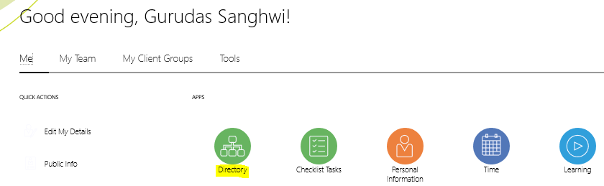
- Search by Name
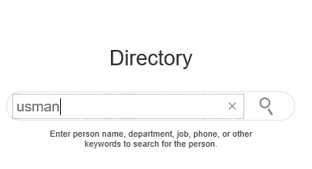
- Select the Staff name
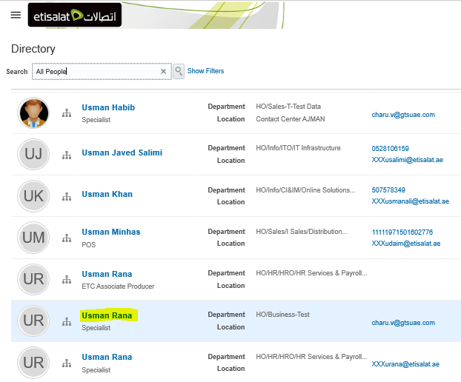
- To view the organization hierarchy of the staff, click on Hierracy icon on left hand side(1) or “View in Organization Chart” link.
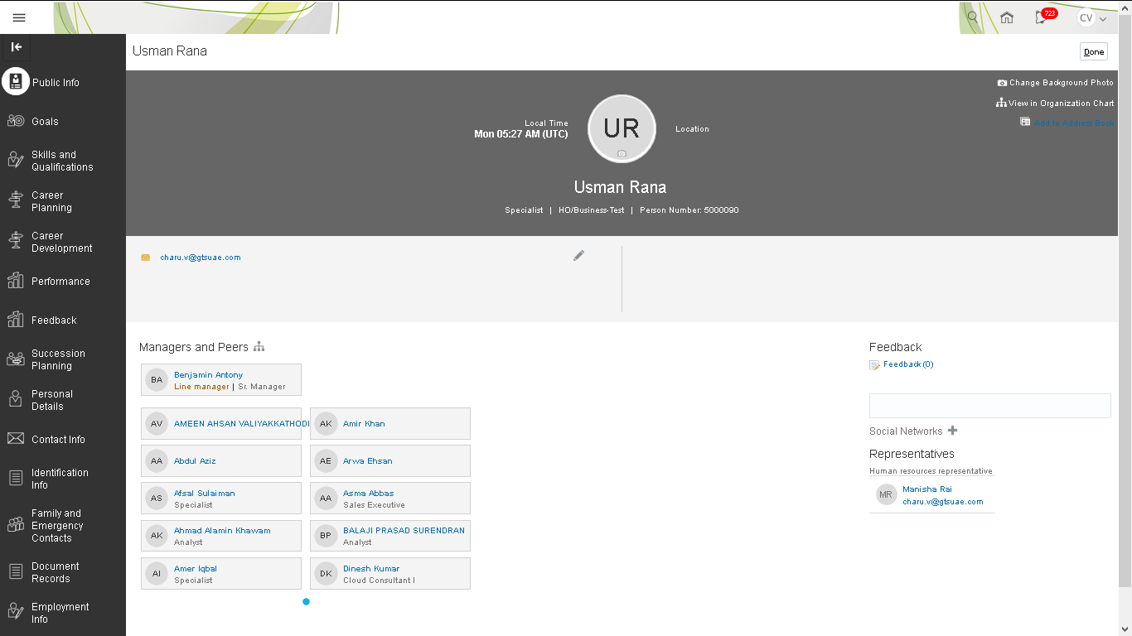
- It will open the pictorial version of the hierrachy as shown below. You can access direct/indircect reports of the Staff(s) from this page.
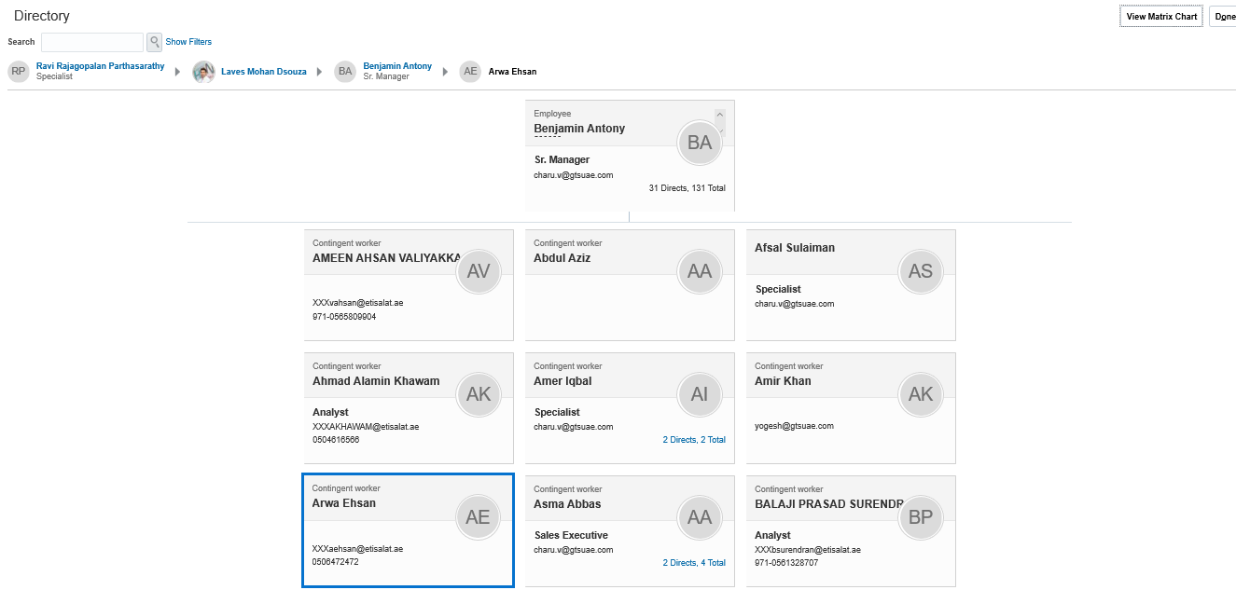

8. Learning

Learning module is integrated with Totara which will send learning history of the Staff(s).
- In the My Team, click on Learning icon from the home page.
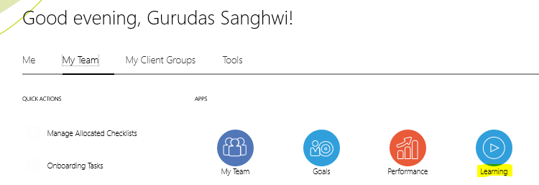
- The below page will show Learning history of the direct repartees.
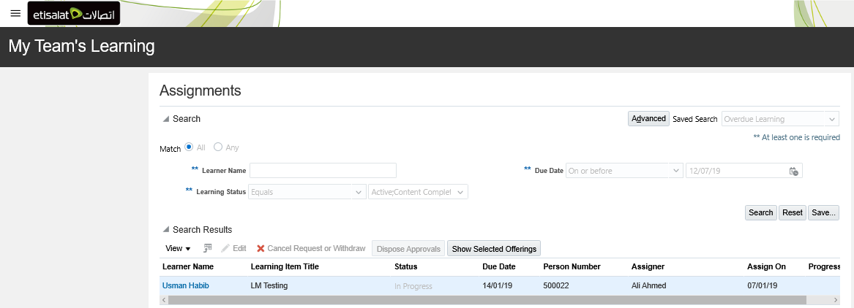

9. Delegation of Access for Approvals

- Click on bell icon on the Home page and then Show All
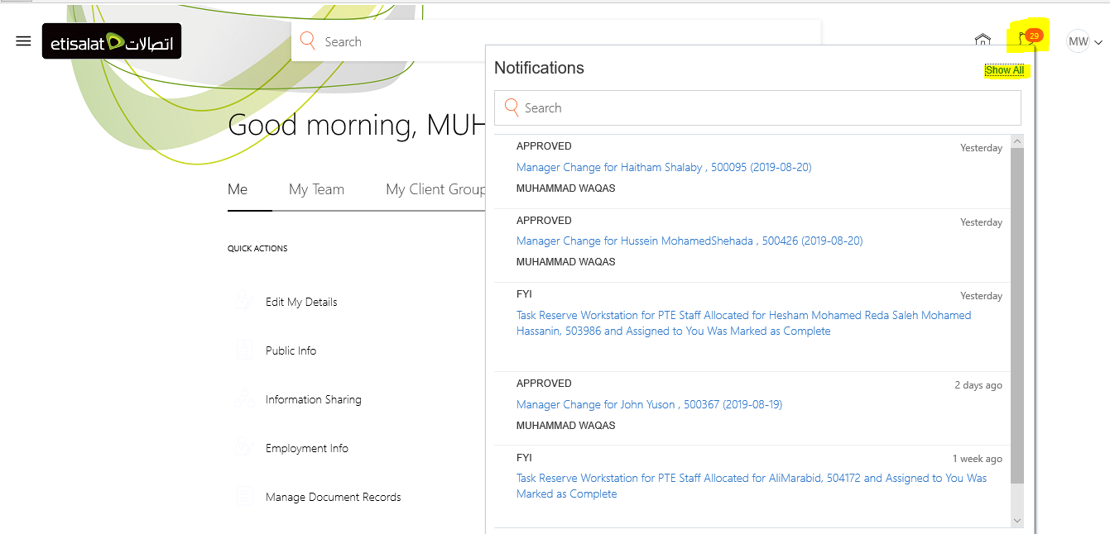
- Click on Worklist

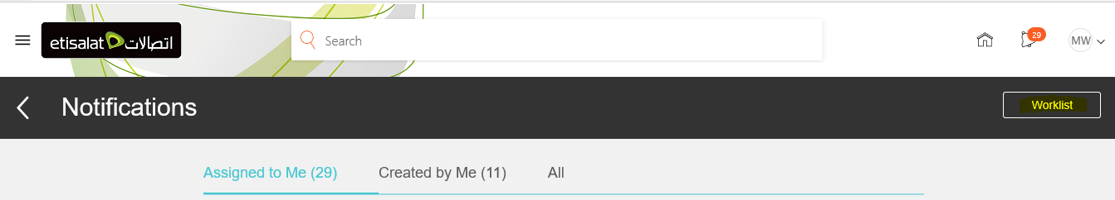

- On the next age, click on your name and then select Preferences from the drop down.

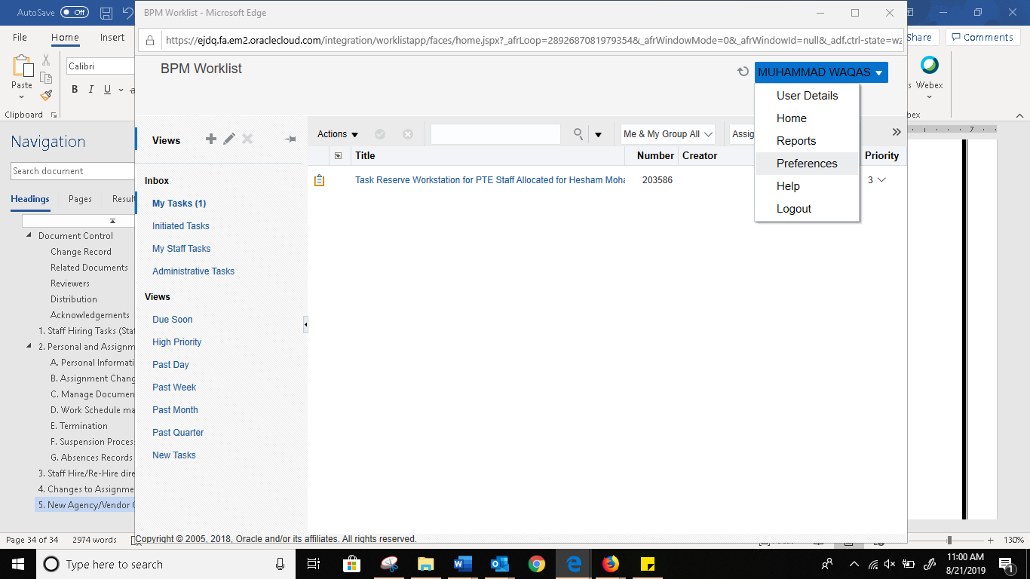

- In the next vacation rules page, enter the below details and save.
- Check Enable vacation period checkbox
- Enter start and end date of delegation
- Select Delegate to radio button
- Search and then select required person to delegate your tasks to
- Click on Save to save the changes.

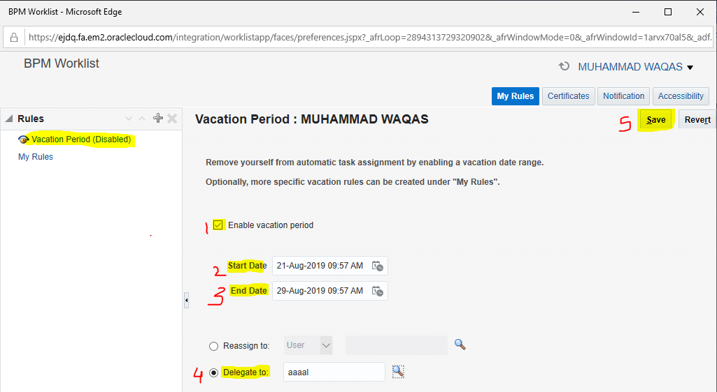

As per the delgation rules, the concerned person o whom delegation has been granted will receive tasks or email and notifications for the targeted time frame.

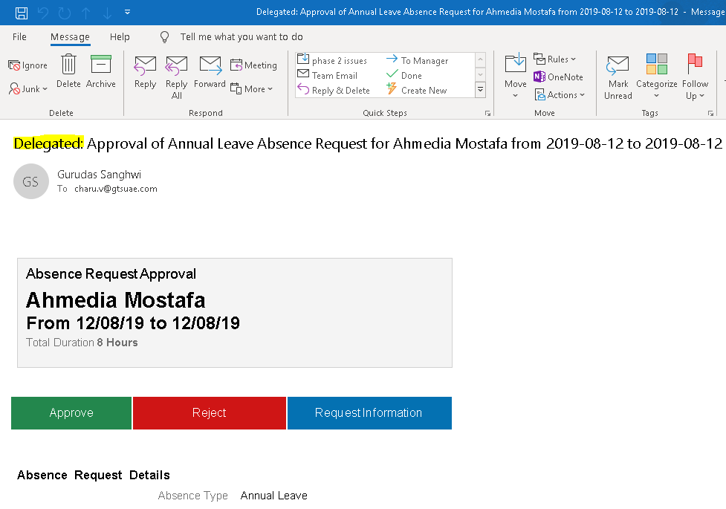

10. Role Delegation and Vacation Rule/Approval Delegation Short Cut

a. Roles Delegations:
From this function manager will be able to delegate his line manager role to any other manager and that person will be able to do all manager related task for his direct reporting staff in his absence.

Navigation:
Login to HR4us > Me > Roles and Delegations > Role Delegations > Add

Click on Roles and Delegations
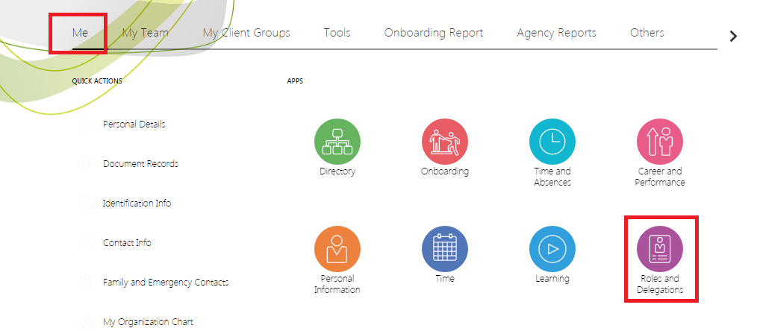
Then in Role Delegations click Add
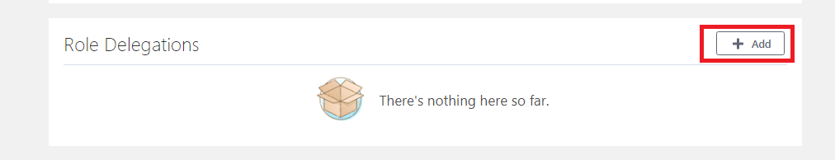
Fill the below form and click save
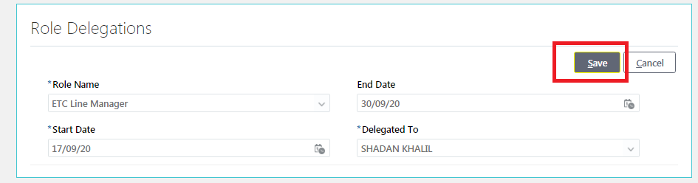
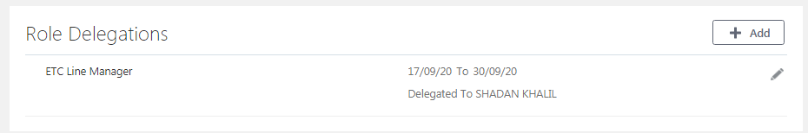

Once saved other person will get below notification and would able to all perform manager related tasks for your direct report such as checking and submitting/approving timecards etc.
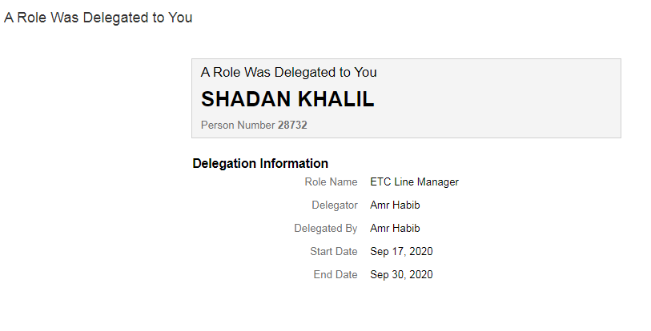

To revoke the role delegation before end date follow the below steps.

Click on Roles and Delegations

Then in Role Delegations Click on Edit button
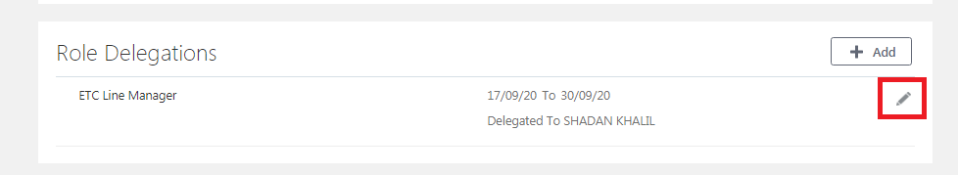

From the below screen either change the end date and click save or delete record. Role delegation access will be revoked
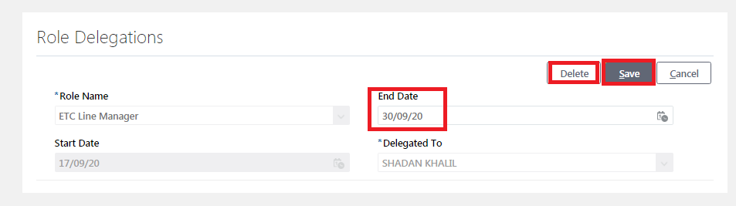

b. Approval Delegation/Vacation Rule Short Cut:
This link is short cut to go to Approval Delegation or vacation rule management page.
Navigation:
Login to HR4us > Me > Roles and Delegation

Click on Roles and Delegations

Then click on the below link available in the Role delegations page
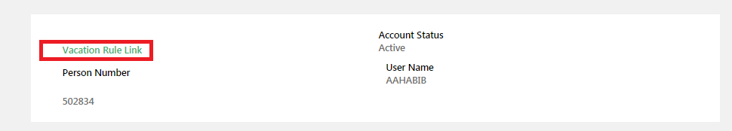
This link will take to same page where you are doing approval delegation as of now, after that follow the same ‘Delegation of Access for Approvals’ available in this document already point no. 9 ‘Delegation of Access for Approvals’.

